**FORM CUSTOMIZATION ASSIGNMENT**

1. What are the forms in NetSuite? What type of forms are present in NetSuite? Explain.

Forms in NetSuite are the templates that define how we enter, view, or edit data. They let you control what information is shown, how it’s organized, and what fields users can fill out.

1. **Transaction Forms**

These are used for recording business activities like sales, purchases, and payments.

Ex - when creating a sales order or an invoice, the form we use is a transaction form.

1. **Entry Forms**

These forms are used to input basic information about entities, like customers, vendors, or employees. Ex - When we fill out details for a new customer or vendor.

1. **Advanced PDF/HTML Templates**

These are for customizing how documents like invoices, purchase orders, or packing slips look when printed or emailed. We can format them with your branding and design and signature, company logo etc.

1. **Custom Forms**

If the standard forms don’t meet our needs, we can create custom forms. For example, we can remove unnecessary fields or add new ones based on our requirements.

1. What is the navigation to create a form in NetSuite?

To create a custom form, navigate to, Customization -> Forms -> Select the form as per your requirement.

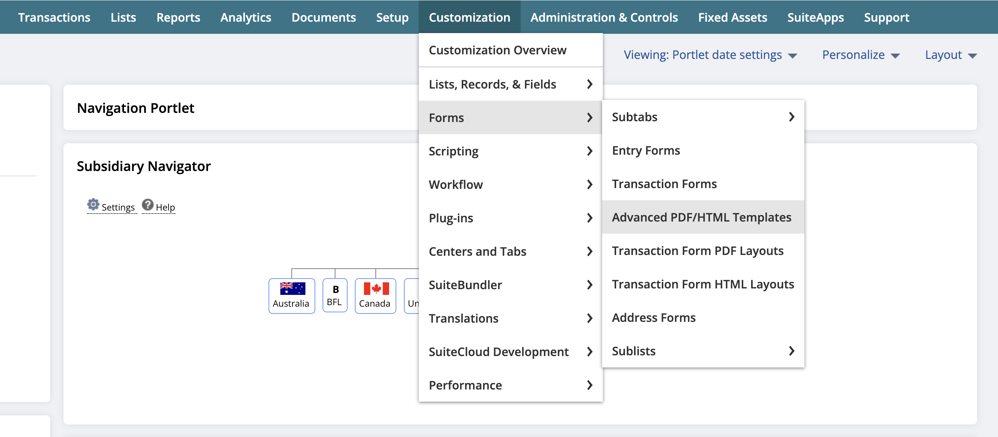

1. Step 1 - Navigate to, Customization -> Forms -> Entry Forms.

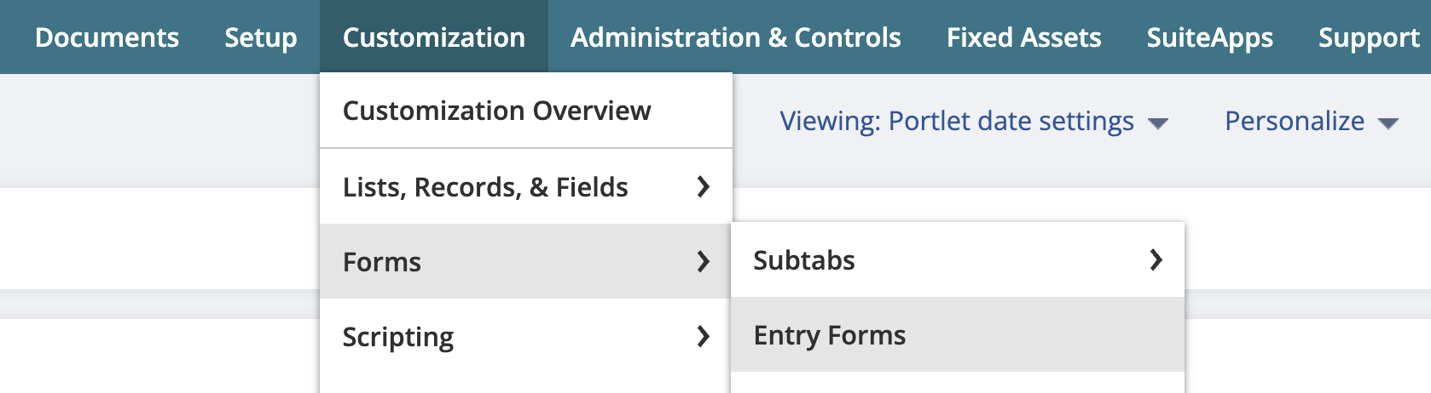

Step 2 – Now you will get a list of preexisting forms. Select anyone and click on Customize.

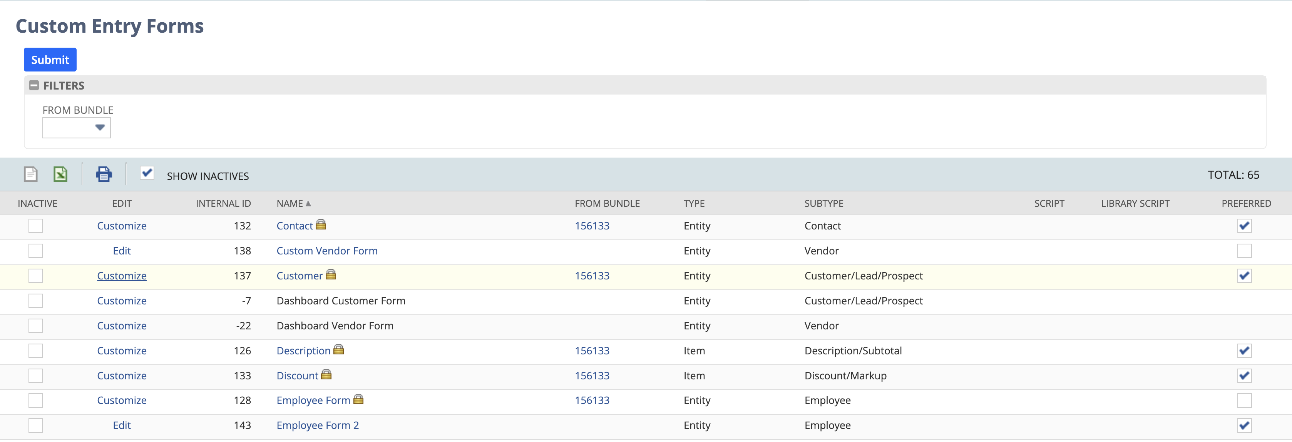

Step 3 – Now Enter a name for your custom entry form and mark all the mandatory fields. Then check the box ‘Select as preferred’.

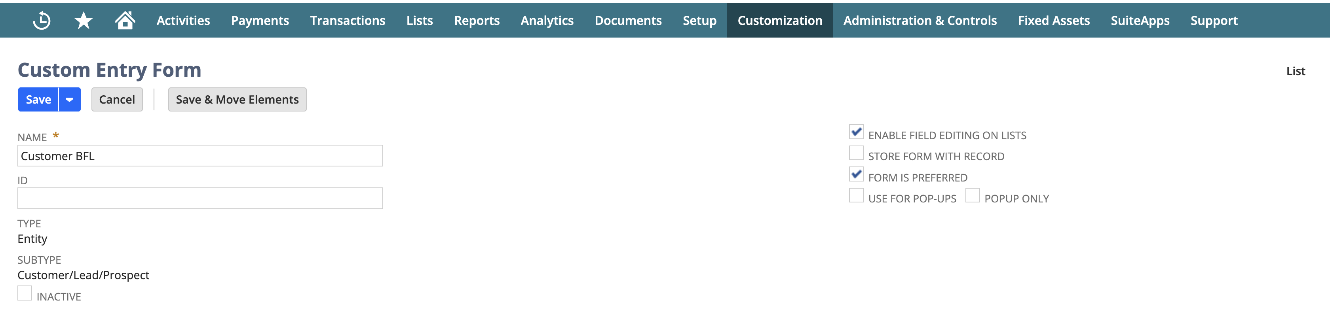

Step 4 – Now check the box of email and phone under mandatory column in Fields subtab. Now click on Save.

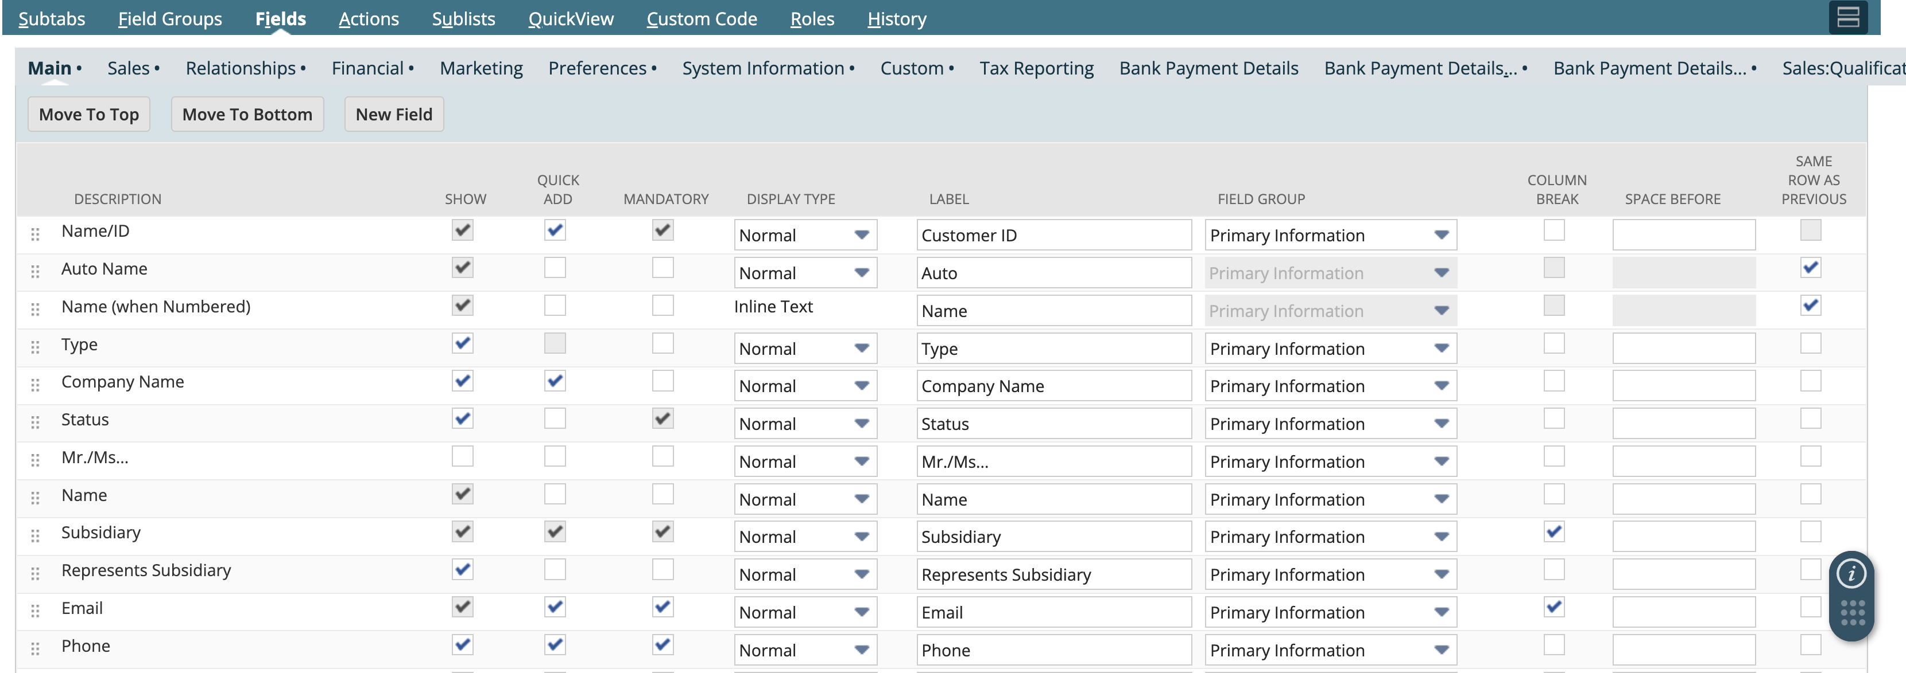

Step 5 – Now you can see that EMAIL and PHONE fields are mandatory for this Customer BFL form.

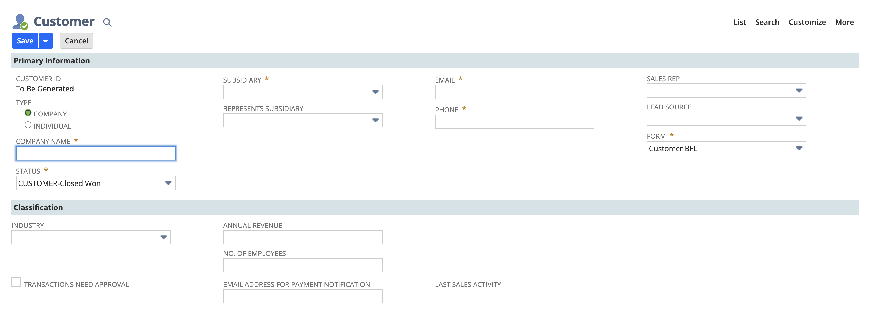

1. Step 1 - Navigate to, Customization -> Forms -> Entry Forms.



Step 2 – Now from the list open the vendor form to customize.

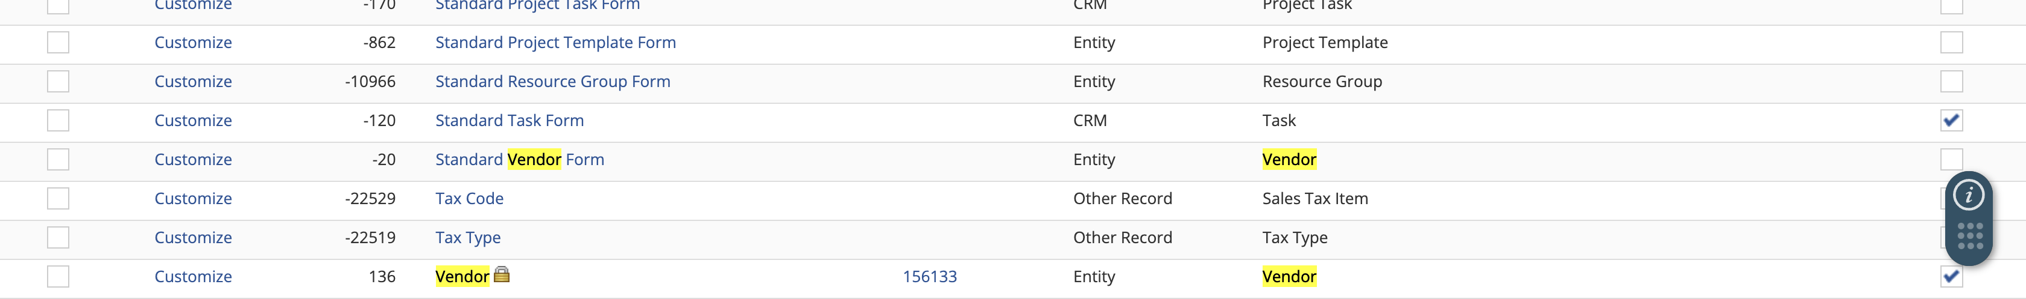

Step 3 – Now under Role subtab, check the CEO, CFO and Accountant checkbox. Then click on Save.

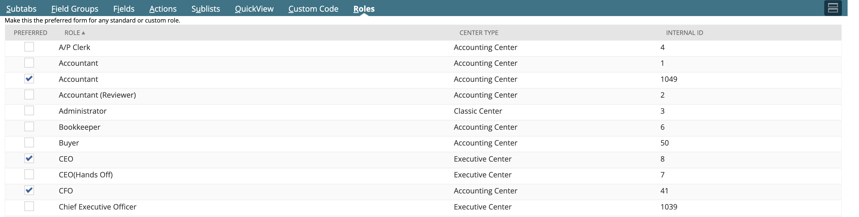

Step 4 – Now we can see that our Accountant role we have a new vendor form.

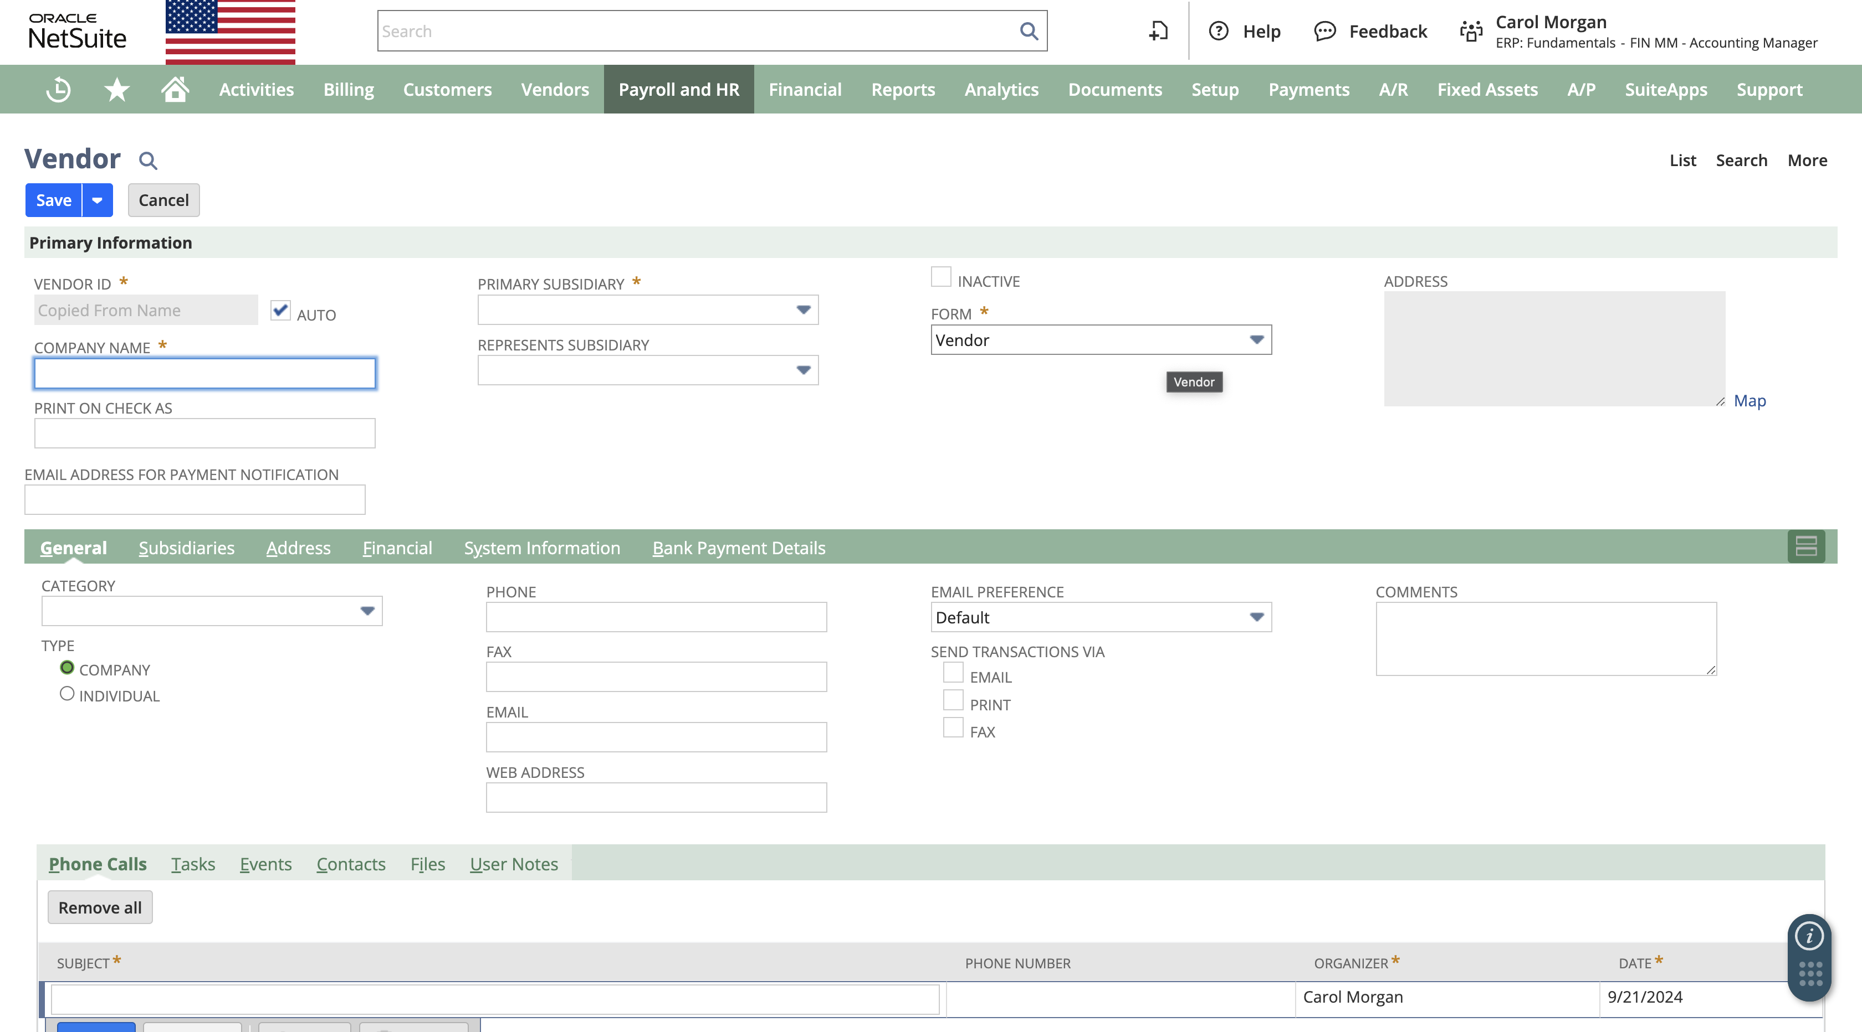

1. Adding two new custom fields -> customer number -> customer new mail id.

Step 1 – Similarly, Navigate to, Customization -> Forms -> Entry Forms.

Step 2 – Now from the list of entry form select the vendor and click on edit to customize it.

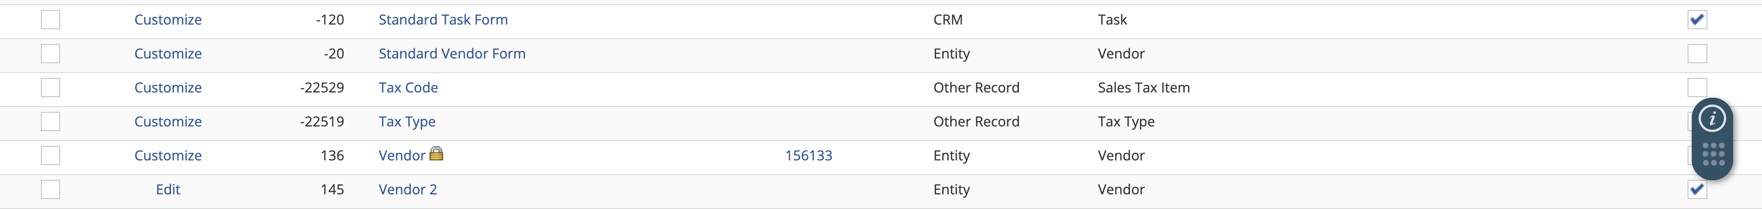

Step 3 – Now under the Field subtab, click on New Field to create a new field.

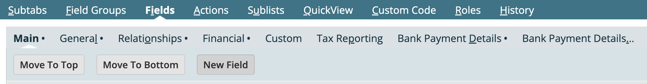

Step 4 – Now give the label and where it should apply to and fill out all the necessary fields. Select Applies to and under Display subtab, select the display as Main.

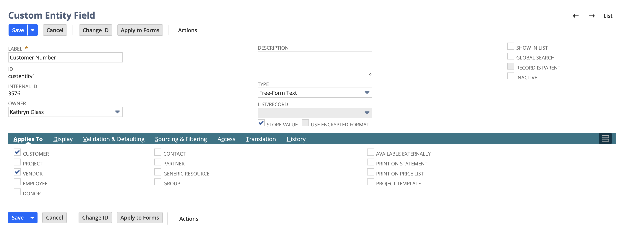

Step 5 – Now you can see two custom fields have appeared in the vendor form.

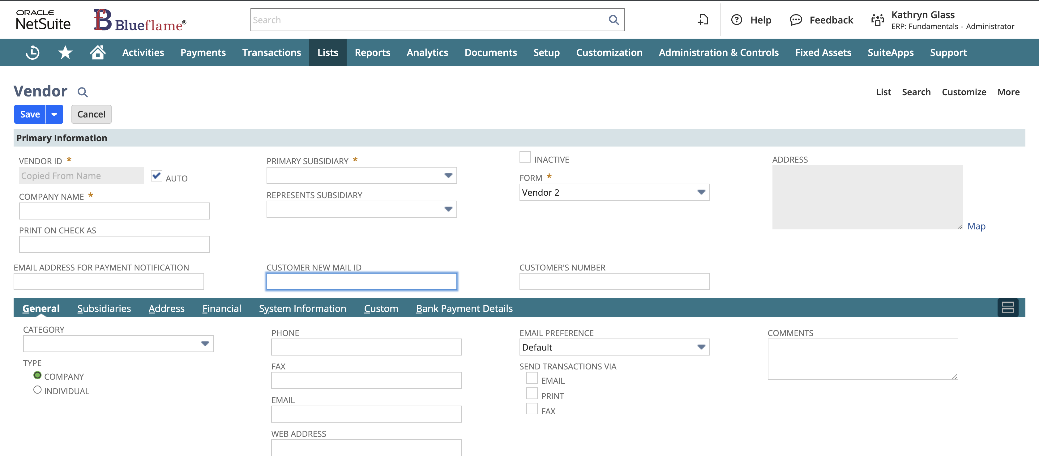

1. Edit the button to new phone no. -> new email id.

Step 1 – Similarly, Navigate to, Customization -> Forms -> Entry Forms.

Step 2 – Click on the vendor form.



Step 3 – Now go to Fields subtab, and under LABEL column update those field name accordingly.

Then click on Save.

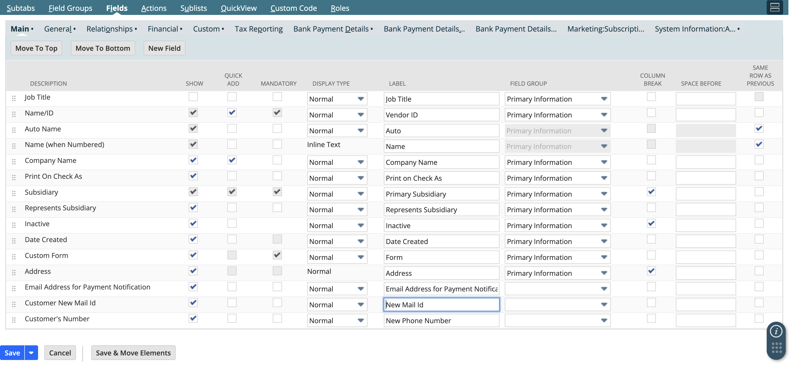

Step 4 – Now we can find the updated field name.

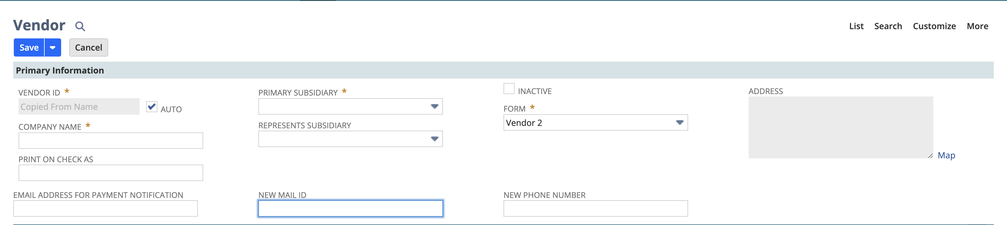

1. Step 1 - Navigate to, Customization -> Forms -> Entry Forms.
2. The Column Break in NetSuite forms is used to split fields into different columns when laying out the form. This helps to organize the form visually and make it more user-friendly.

Step 1 – Navigate to, Customization -> Forms -> Entry Forms.

Step 2 – Go to the vendor record and under Fields subtab check the box under COLUMN BREAK column. We select Represent Subsidiary in our case. Then click on Save.

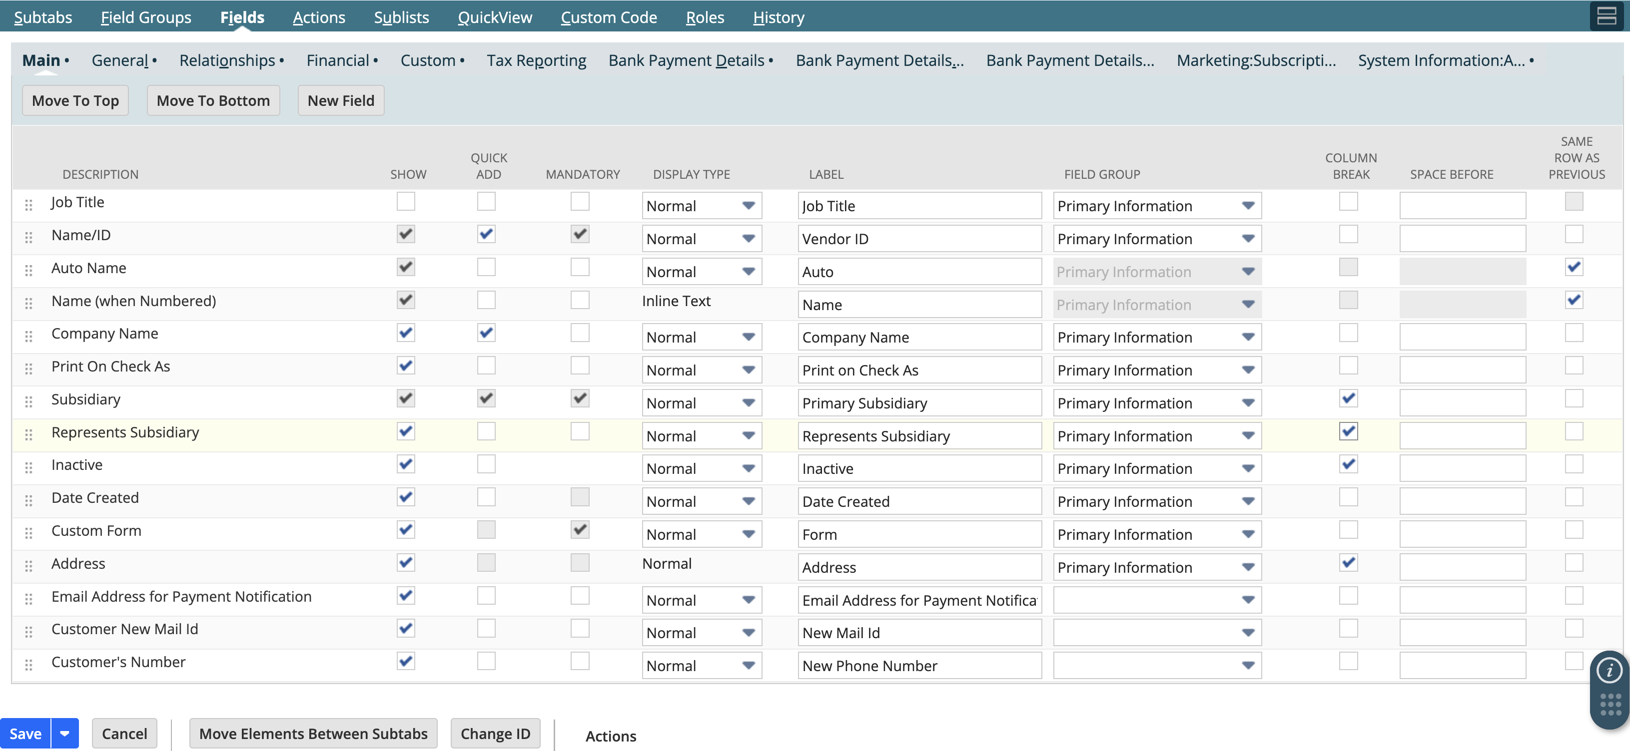

Step 3 – Now we can compare the previous appearance and current appearance of the page.



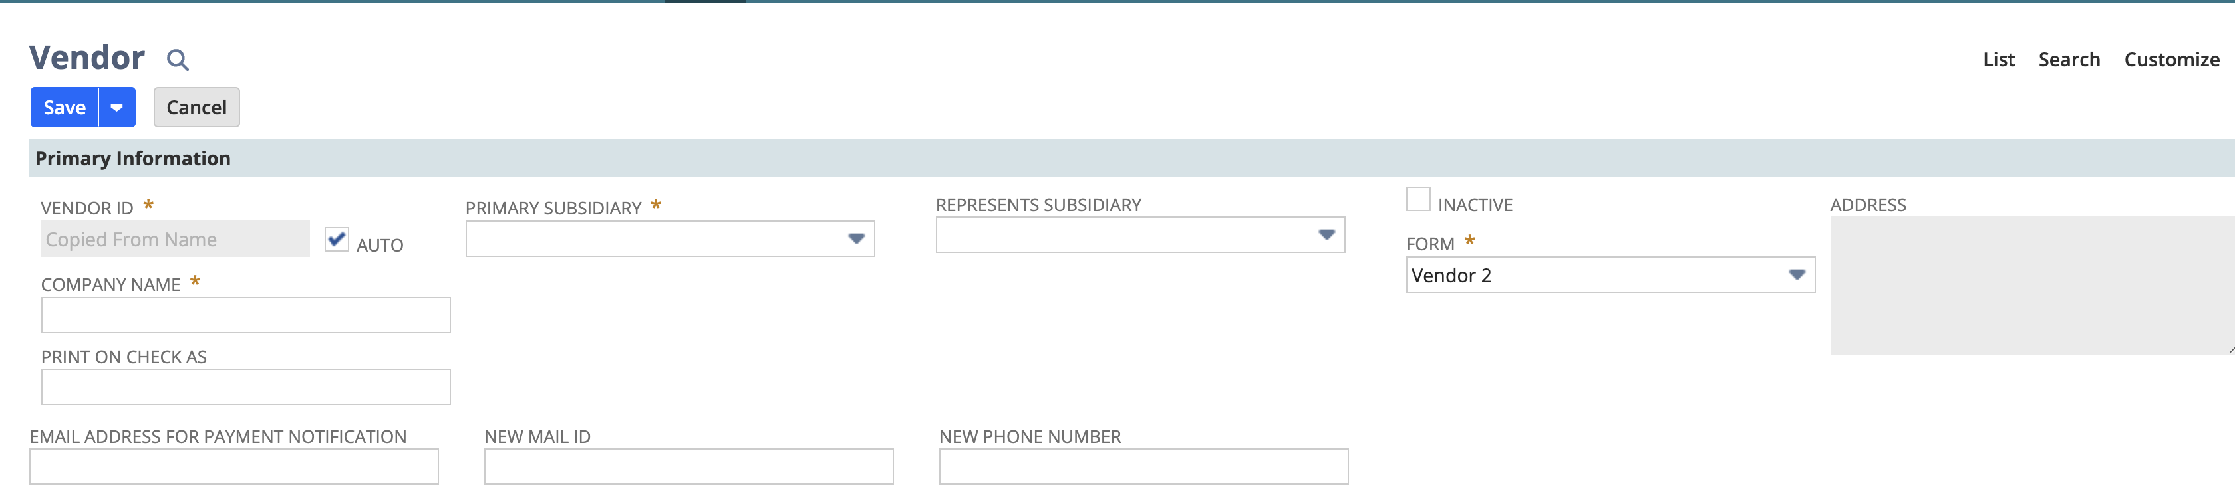

Step 1 – Navigate to, Customization -> Forms -> Transaction Form.

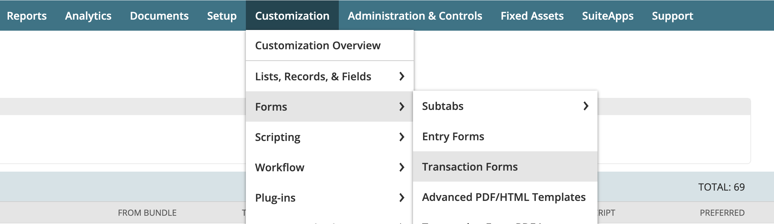

Step 2 – Select Sales Order from the list and click on Customize.

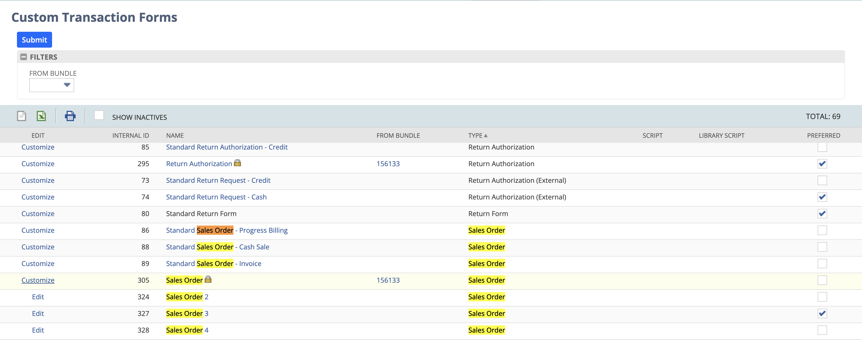

Step 3 – Now provide the NAME and change the print template and email template to Sales Order.

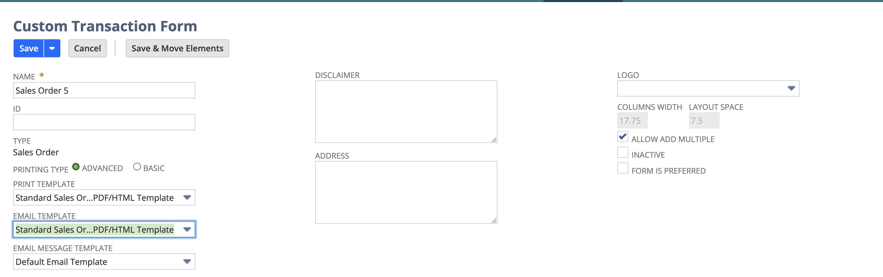

Step 4 – Now click on Save. So, the next time it will give us the proper template as we customized it.

**Display Type** controls how a field appears and behaves on a form. Below are the three types of display type.

**1. Normal**

* The field is fully editable and visible.
* This is the default display type when you want users to enter or change data in the field.

### **2. Inline Text**

* The field is **read-only** and appears as text on the form. Users can see the data but **cannot edit** it.
* Ideal for displaying information that you don’t want users to modify (e.g., a system-generated value like a transaction ID).

### **3. Disabled**

* The field is **visible but grayed out** (disabled), meaning users cannot interact with or change the field’s value.
* Used when a field needs to be displayed but should be **non-editable** for users (e.g., when a field’s value is controlled by workflow or another condition).

Here we select the new mail id to disabled.

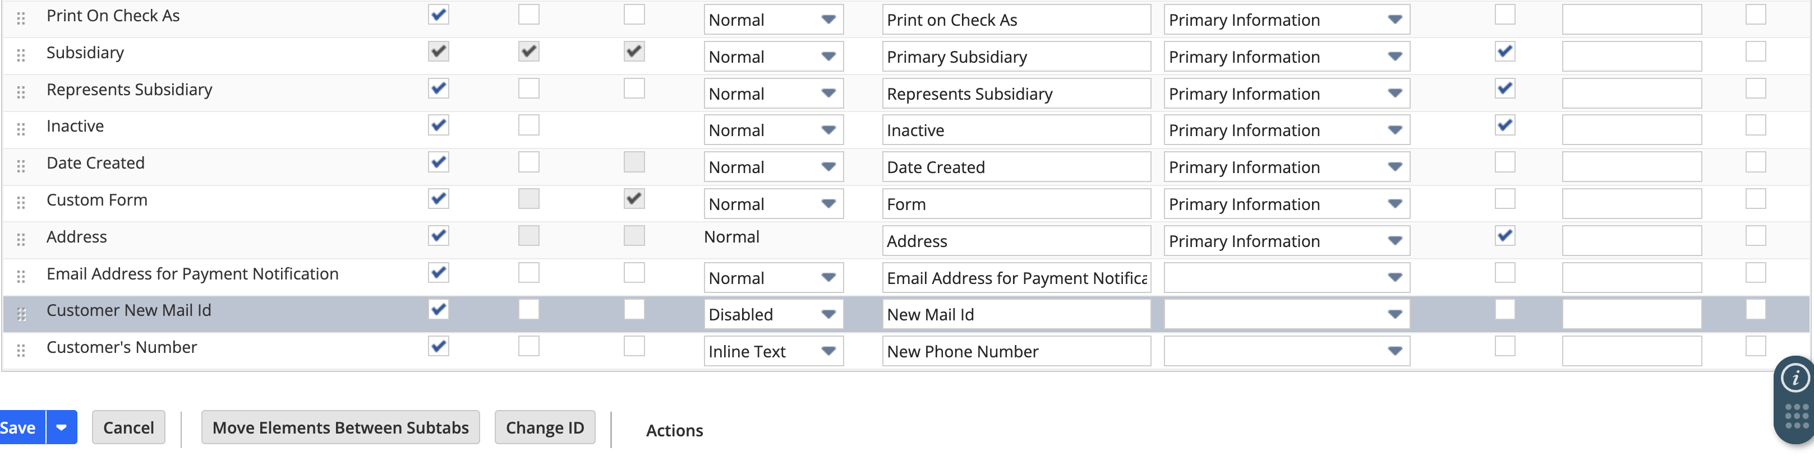

In the below image we can see the change after saving the form, the mail id field is grayed out.

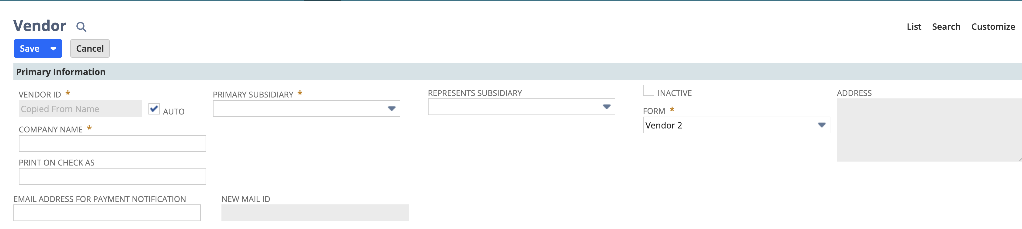

The Quick View feature in NetSuite allows users to view essential information about a record without fully opening it. Users can hover over or click a record to see key details (like a customer’s contact info or transaction summary) without loading the entire record page.

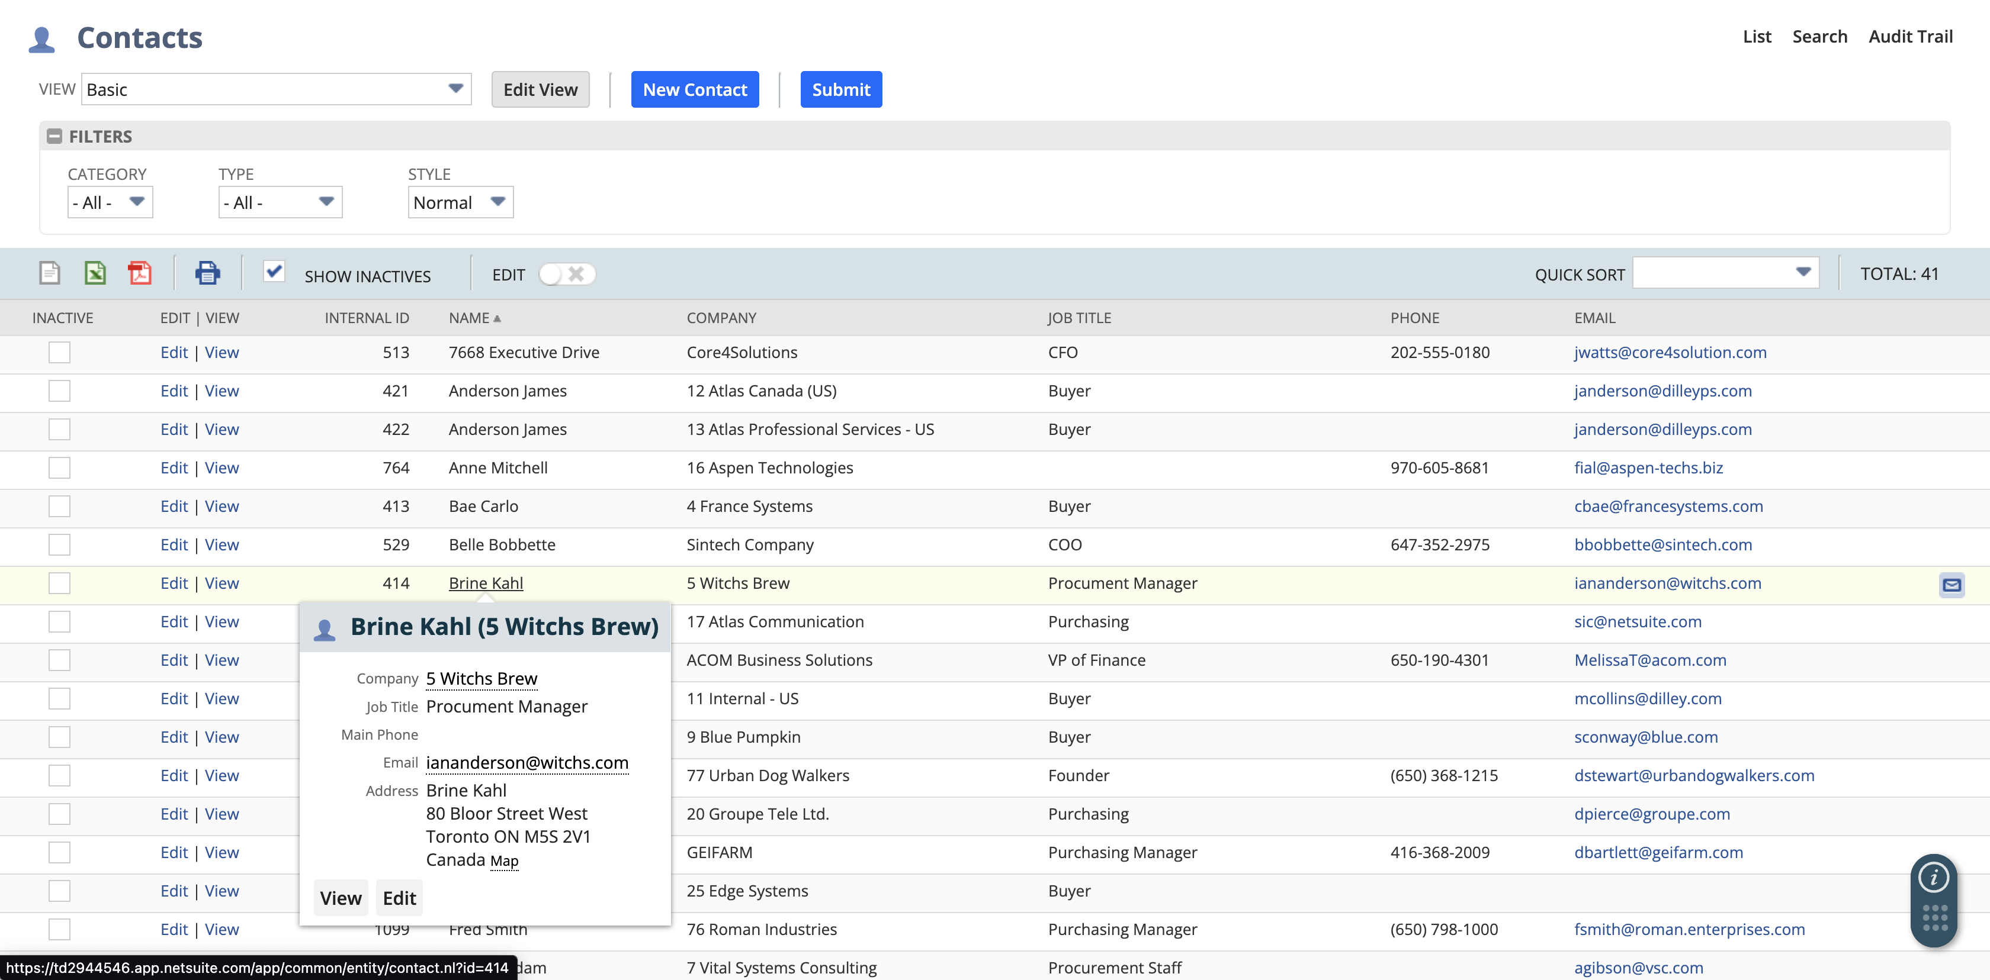

* We can also add some more details if we want access those in Quick View.
* We can also add, remove, and rearrange.

Step 1 – Navigate to, Customization -> Forms -> Entry Forms.

Step 2 – Now select any form (for ex - vendor) and edit it.

Step 3 – Now under Quick View subtabs we add Type to access it in Quick View. Then click on Save.

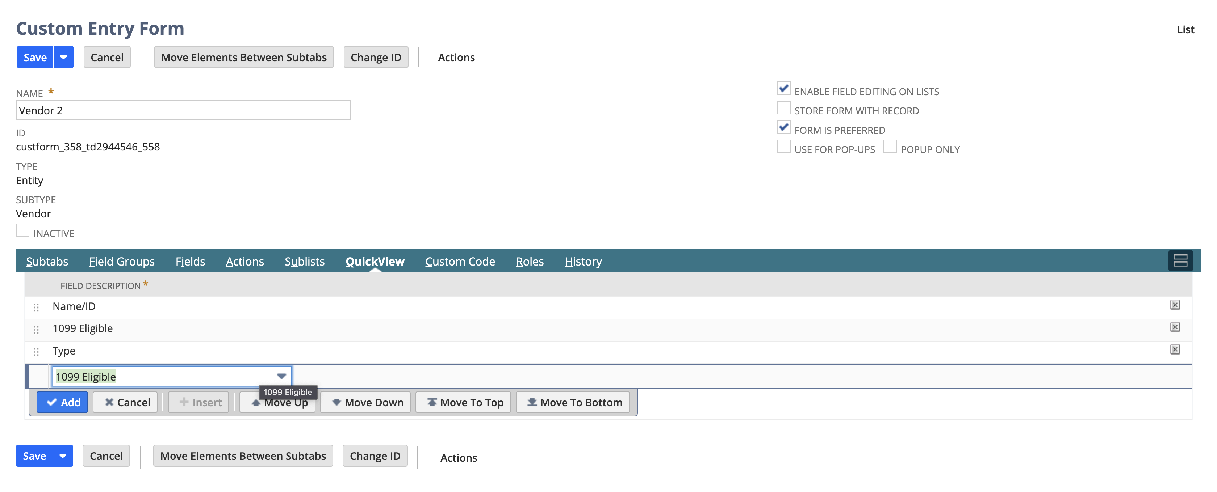

Step 4 – Now we can see Type under a vendor record after quick view it.

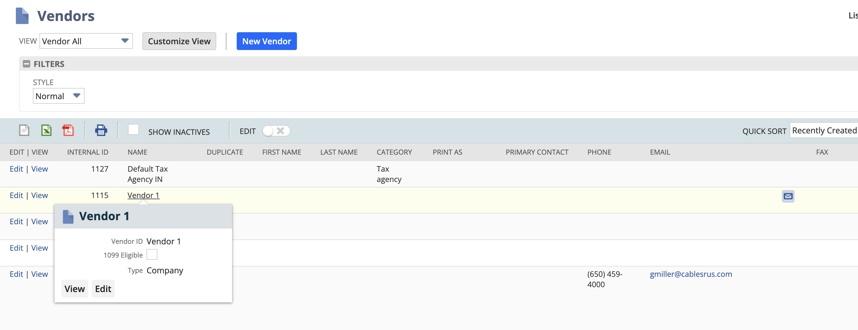

1. S

Step 1 - Navigate to Customization -> Forms -> Transaction Forms.

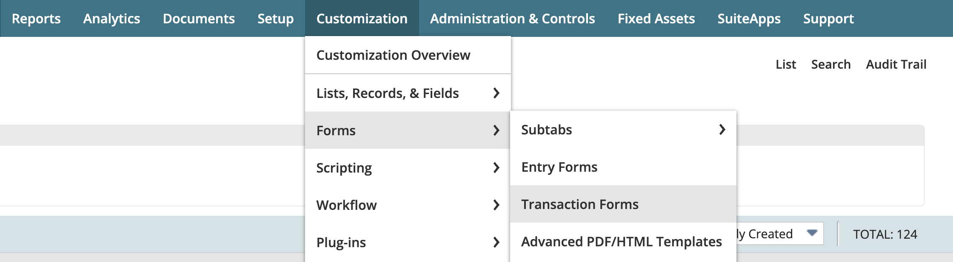

Step 2 – Now find the purchase order from the list and click on Customize.

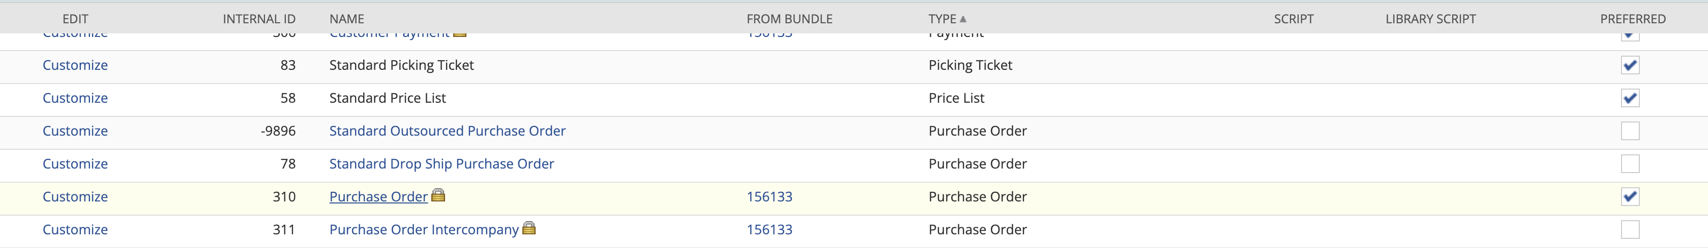

Step 3 – Now under the main subtab click on ‘New Field’ button.

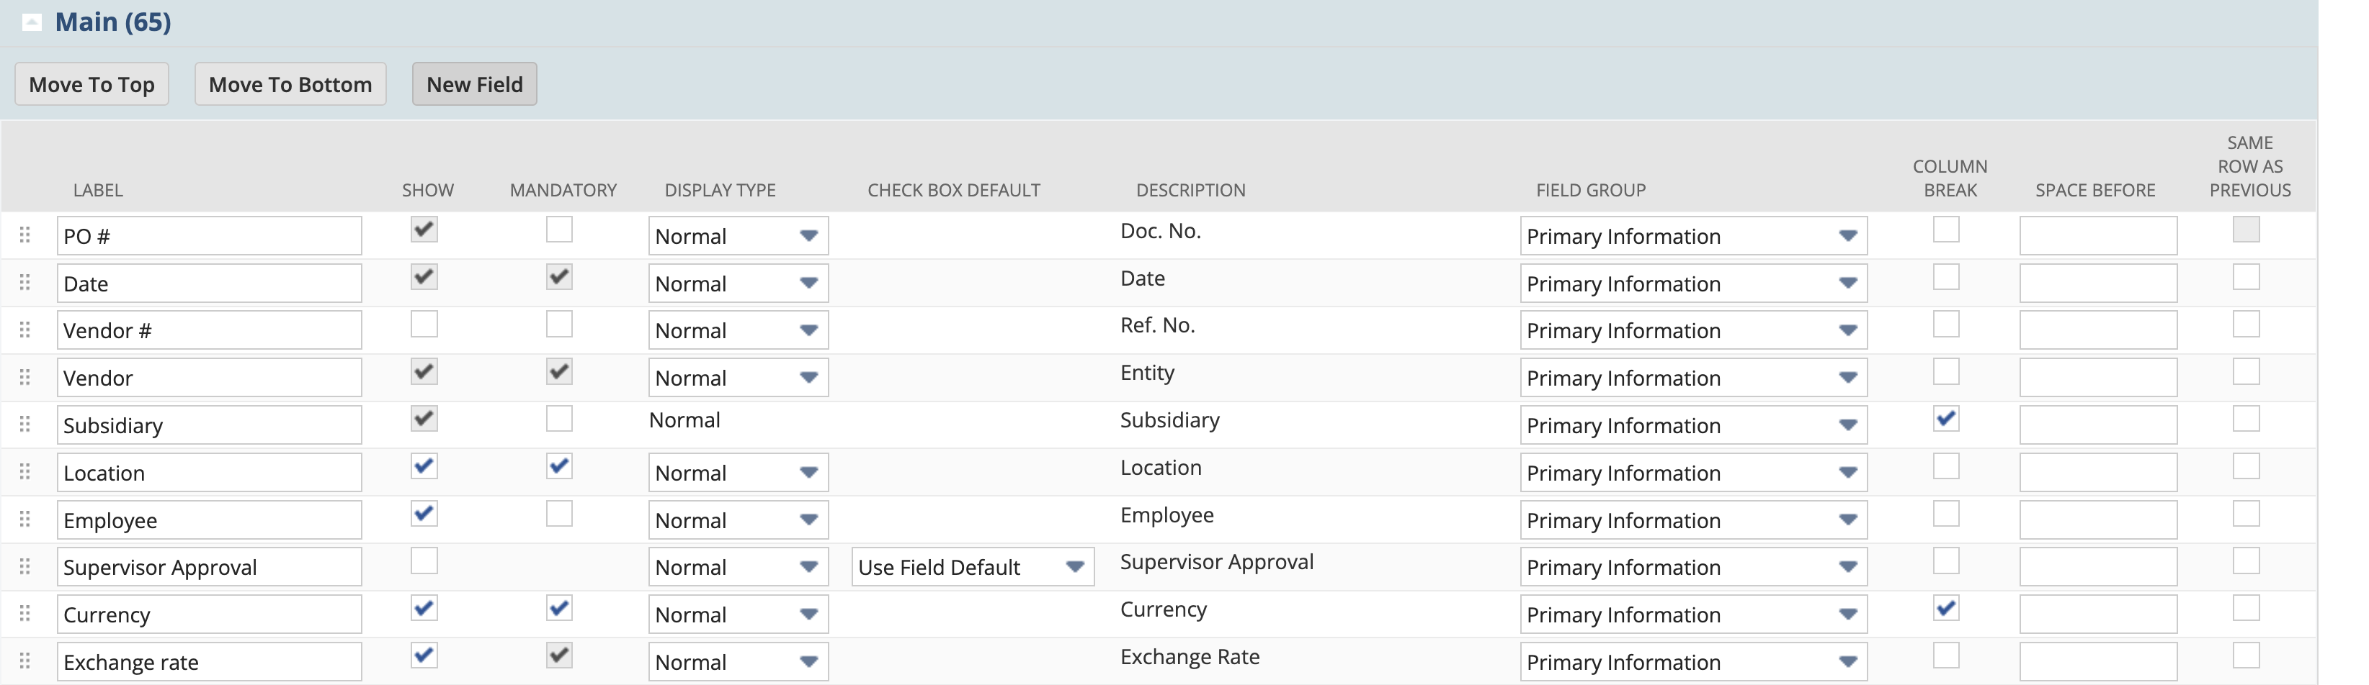

Step 4 – After opening the new field page, give the label to the field and under Applies To subtab check the purchase box to apply on purchase order. Now make sure you click on ‘Apply to forms’ button to apply it on custom form only.

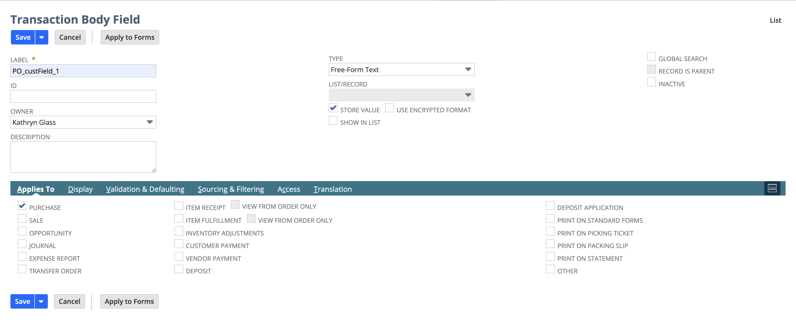

Step 5 – Now check the box under the Show column and click on Submit.



Step 6 – Now Navigate to, Transaction -> Purchase -> Purchase order. We will be able to find the custom field we just added as “PO_custField”. Similarly, we can create more fields by following all these above steps.

